Rizvi College of Engineering Data Structure Lab

***Department:*** Computer Engineering (Sem III)

***Class:*** *Second Year (S.E)*

***Subject:*** Data Structures Lab

***Expt. No.7B***

***Title: Insertion Sort***

Computer Department (Sem-3) Experiment No-7B Page-1

Rizvi College of Engineering Data Structure Lab

***Department:*** Computer Engineering (Sem III)

***Class:*** *Second Year (S.E)*

***Subject:*** Data Structures Lab

***Expt. No.8***

***Title: Merge Sort***

Computer Department (Sem-3) Experiment No-8 Page-1

**CODE: -**

#include<stdio.h>

#include<stdlib.h>

int main(void)

{

int array[100],i,j,n,k,temp;

printf("Enter the length of the array:\n");

scanf("%d",&n);

printf("Enter the elements of the array:\n");

for(i=0;i<n;i++)

scanf("%d",&array[i]);

printf("Unsorted elements of the array are:\n");

for(i=0;i<n;i++)

printf("%d\n",array[i]);

for(i=1;i<n;i++)

{

temp=array[i];

j=i-1;

while(array[j]>array[j+1] && j>=0)

{

array[j+1]=array[j];

array[j]=temp;

j--;

}

for(k=0;k<n;k++)

printf("%d ",array[k]);

printf("\n");

}

printf("Sorted elements of the array are:\n");

for(i=0;i<n;i++)

printf("%d\n",array[i]);

return 0;

}

**OUTPUT: -**

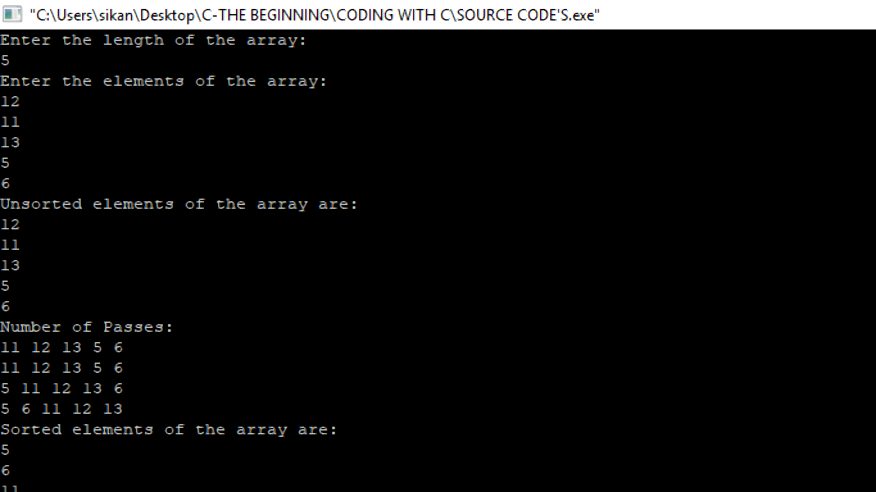

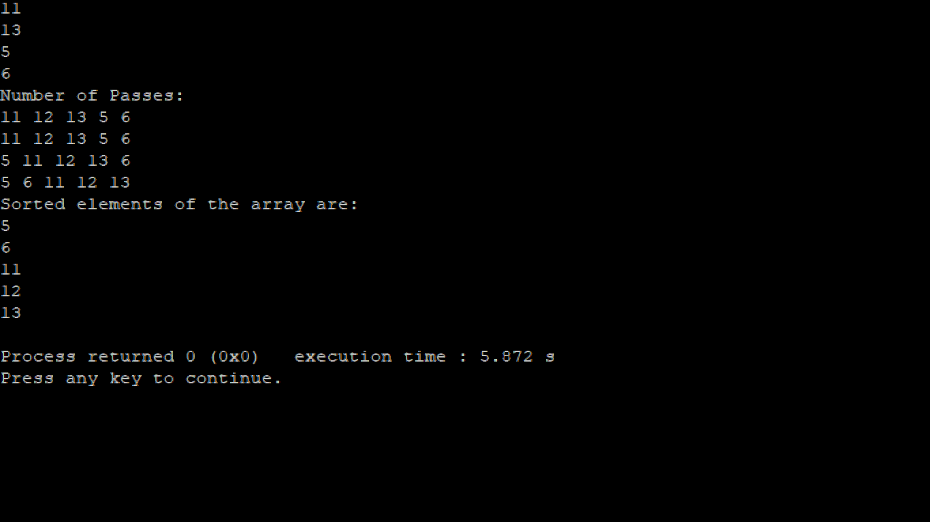

**CODE: -**

#include<stdio.h>

#include<stdlib.h>

void merge(int a[100],int beg,int mid,int end)

{

int i=beg,j=mid+1,index=beg,temp[100],k;

while(i<=mid && j<=end)

{

if(a[i]<a[j])

{

temp[index]=a[i];

i++;

}

else

{

temp[index]=a[j];

j++;

}

index++;

}

if(i>mid)

{

while(j<=end)

{

temp[index]=a[j];

index++;

j++;

}

}

else

{

while(i<=mid)

{

temp[index]=a[i];

index++;

i++;

}

}

for(k=0;k<end+1;k++)

a[k]=temp[k];

}

void mergesort(int a[100],int beg,int end)

{

int mid;

if(beg<end)

{

mid=(beg+end)/2;

mergesort(a,beg,mid);

mergesort(a,mid+1,end);

merge(a,beg,mid,end);

}

}

int main(void)

{

int array[100],i,j,n,k,temp;

printf("Enter the length of the array:\n");

scanf("%d",&n);

printf("Enter the elements of the array:\n");

for(i=0;i<n;i++)

scanf("%d",&array[i]);

printf("Unsorted elements of the array are:\n");

for(i=0;i<n;i++)

printf("%d\n",array[i]);

mergesort(array,0,n-1);

printf("Sorted elements of the array are:\n");

for(k=0;k<n;k++)

printf("%d\n",array[k]);

return 0;

}

**OUTPUT: -**

